**Durham College**

**Artificial Intelligence Analysis, Design and Implementation**

**Capstone Term II - AIDI 2005 – 01**

**_________________________________________**

**Facial Attendance Management System**

**Group-12 Members: -**

1. **Himanshu Dhiman - 100721563**
2. **Shubham Dikshit - 100688204**
3. **Harin Shah - 100674815**
4. **Ankitkumar Patel – 100717791**

**Date: - 06- March- 2020**

**Prototype**

**Technologies**: -



For processing the information in real time, we are going to use React, this will also help us to create our front end.

For sending data back and forth we will be using Python Flask and this will also help us to create an API which will request the data and send back the answer.

For database we are going to use PostgreSQL, any other dataset will also work. But because of its simplicity we have decided this.

How it will work?

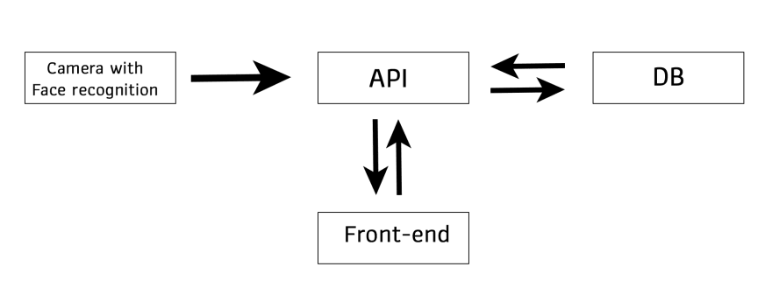

The moment person will stand in front of the camera, it will check in the database if the person’s information is available in the database or not. If the person is appearing for the first time, on the front-end user will get an option to add the person.

First camera will detect the people and get the time of detection, latter send that information to our API. Latter, API would ask DB if the employee as arrived today or not. Then it will consider that student is eligible to be on time and send it back to the DB. On the front-end user will get an option about adding or deleting an employee or student.

The front will send the information to the API that will query DB and process it in front end.

**Feeding Data in the architecture:-**

We have taken 5 images of 5 different people and created a database. Latter we feed that data in the application and when we checked the out-put we got the desired result.

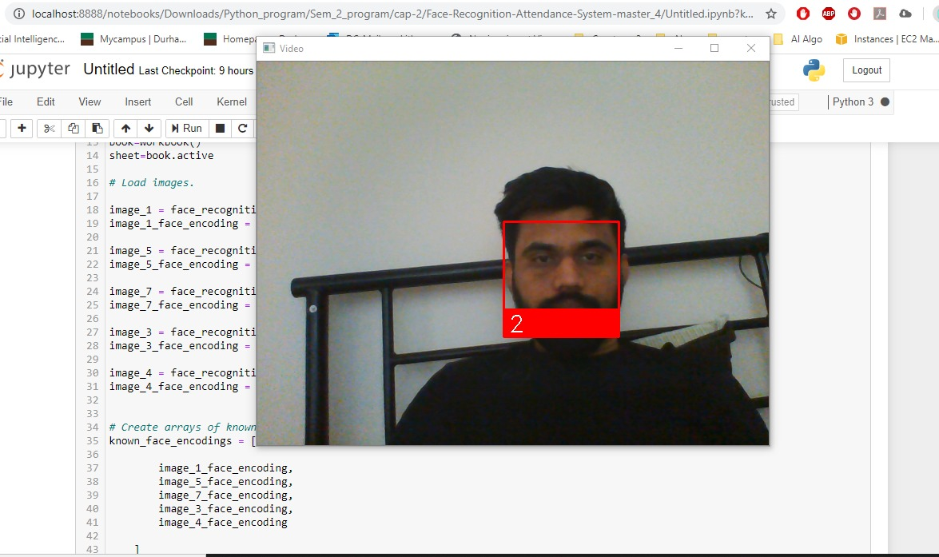

Next, the model has successfully created an excel file with the recorded attendance of the students.